**Task 6 by Dzmitry Shautsou**

# OLTP – Load External References – Normalization of Data

**Task Results:**

* Create sql scripts to show All created Tables and Views – Screenshot
* Create DataFlow: Sketch Diagram of loading external References (MS Visio, MS Paint, MS Word, etc.)
* Create sql: Showing result of data on next objects:
  + t_localizations
  + cu_languages
  + w_lng_links
  + cu_lng_scopes
  + cu_lng_types

(User u_dw_references)

select * from t_localizations;

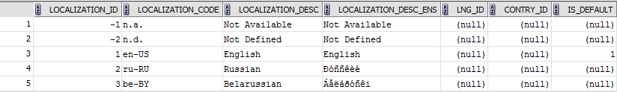

select * from cu_languages;

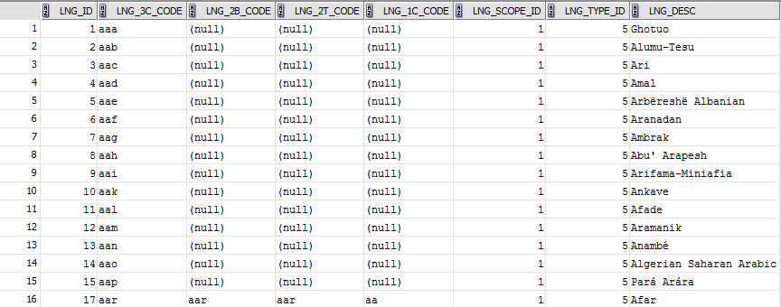

select * from cu_lng_scopes;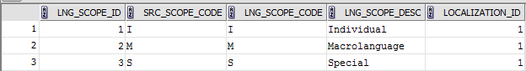

select * from cu_lng_types;

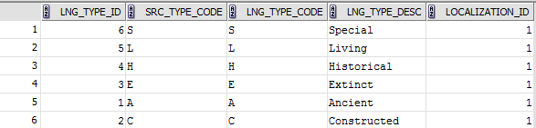

select * from t_lng_links;

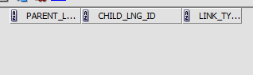

The Physical Diagram of T_Languages below:

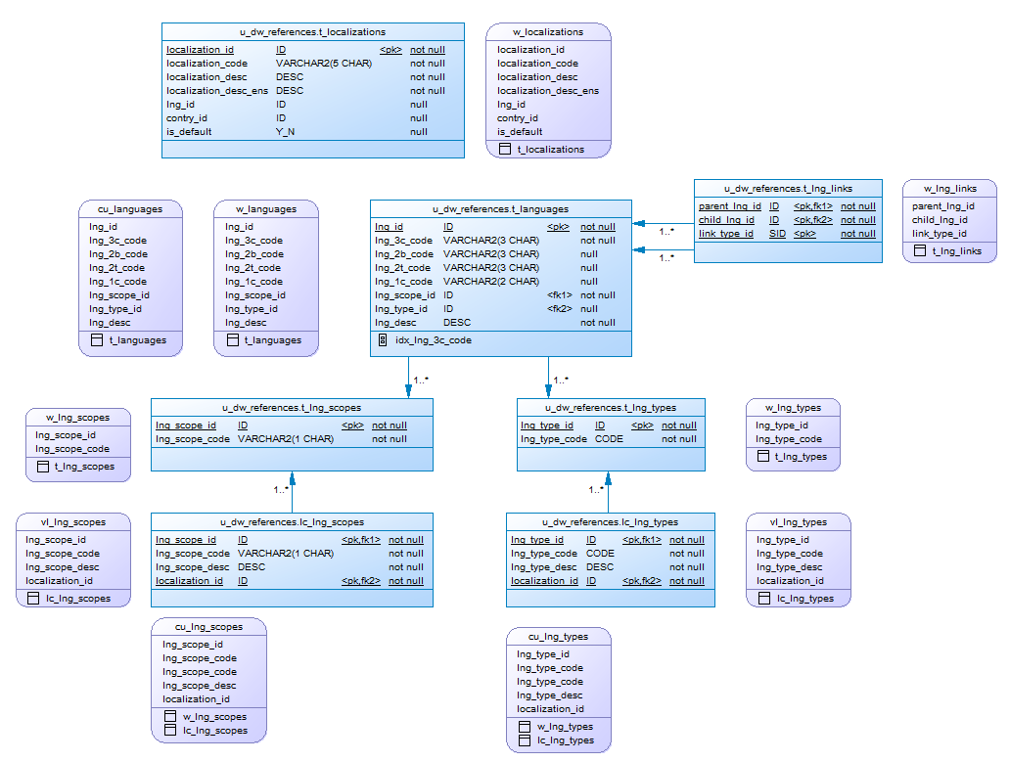

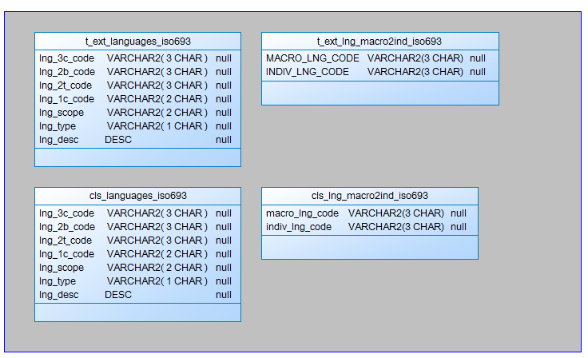

## Task 02 – Create load process for External references T_Countries

**The Main Task** is to develop SQL scripts and install needed objects for load external reference T_Countries.

**Task Results:**

* Create SQL scripts to show All created Tables and Views – Screenshot
* Create DataFlow: Sketch Diagram of loading external References (MS Visio, MS Paint, MS Word, etc.)



* Create SQL: Showing result of data on main objects:

SELECT * FROM CU_COUNTRIES;

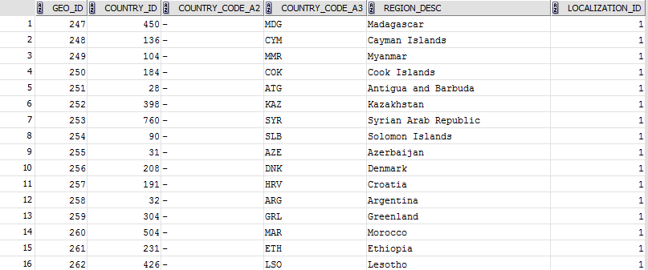

SELECT * FROM CU_GEO_REGIONS;

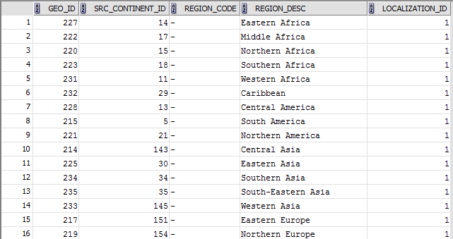

SELECT * FROM CU_GEO_PARTS;

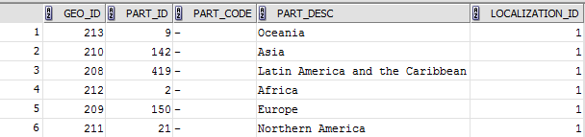

* Prepare The Physical Diagram of T_Countries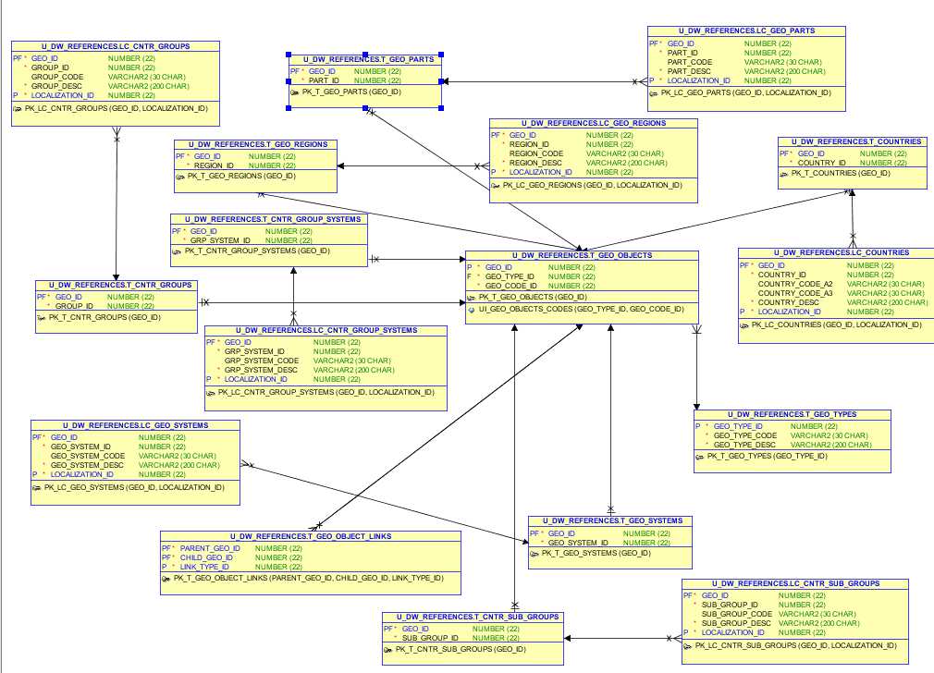

# OLAP – Business analyses task

Create any business analyses task for interesting for your business. The main idea is to use next main dimension:

* Time
* Geo-Location – T_COUNTRIES

## Task 02 – Solution concept – Business background

**The Main Task** is to create Solution concept of yours any business analyses task. You should use Developing Model, that described on MTN.NIX.07.Oracle DB.DWH_courseware06_Star Schema Basics.docx.

**Task Results:**

Create Solution Concept document, which contained next chapters:

Overview

Business Background

Benefit

Requirements

Business Requirements

Technical Requirements

Solution Sketch

Source Tables structure

Summarize Data Plan

(Watch “BusinessProposal.docx” in the same folder)

# OLAP – Develop Star-Scheme and SnowFlake Scheme.

## Task 03 – Develop Star-Scheme physical diagram

**The Main Task** is to create Star Physical diagram and Logical diagram of solution.

**Task Results:**

Create document, which contained next chapters:

* + Physical diagram



* + Logical diagram



## Task 04 – Develop SnowFlake physical diagram

**The Main Task** is to create SnowFlake Physical diagram and Logical diagram of solution.

**Task Results:**

Create document, which contained next chapters:

* + Physical diagram
  + Logical diagram
* **Logical**



* **Physical**
* 